Q.1 Create a product management store with the below features Use array for keeping products Use cases

1) Add the product in the store

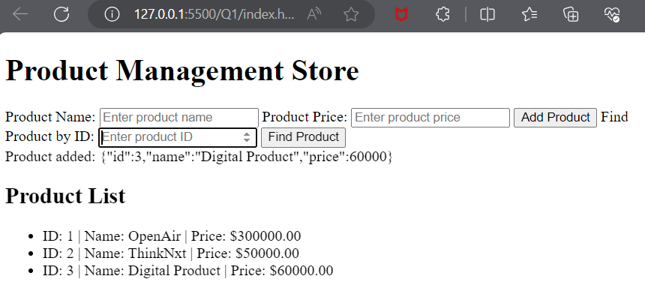

2) Find the product by id

